# DATABASE SYSTEM PRACTICUM REPORT

# MODULE 11

**MY SQL and PYTHON**



**CREATED BY :**

**KURNIAWAN BAGASKARA**

**L200214253**

# INFORMATICS STUDY

# PROGRAM

**FACULTY OF COMMUNICATION AND INFORMATION SCIENCE MUHAMMADIYAH SURAKARTA UNIVERSITY**

TASK

1. Create Code Insert, Update and Delete

Code Insert :

import mysql.connector

from datetime import date, datetime, timedelta

tanggal = datetime.now().date()

cnx = mysql.connector.connect(*user*='root',

*database*='perbankan')

cursor = cnx.cursor()

insert_transaksi = ("INSERT INTO transaksi (id_nasabahFK,

no_rekeningFK, jenis_transaksi, tanggal, jumlah) "

"VALUES (%s, %s, %s, %s, %s)")

data_transaksi = ('10', '100', 'kredit',

tanggal.strftime('%Y-%m-%d'), '100000')

cursor.execute(insert_transaksi, data_transaksi)

cnx.commit()

cursor.close()

cnx.close()

Output :

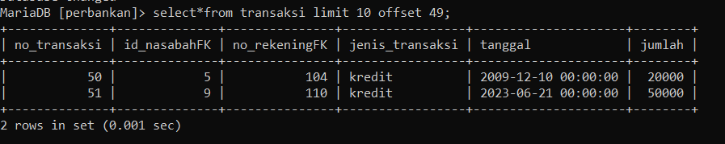

Code Update :

import mysql.connector

cnx = mysql.connector.connect(*user*='root',

*database*='perbankan')

cursor = cnx.cursor()

delete_transaksi = ("DELETE FROM transaksi "

                    "WHERE no_transaksi=%s")

data_transaksi = ('51',)

cursor.execute(delete_transaksi, data_transaksi)

cnx.commit()

cursor.close()

cnx.close()

Output :

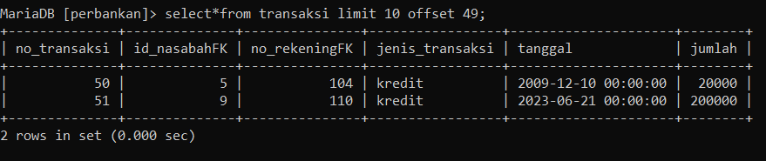

Code Delete :

import mysql.connector

cnx = mysql.connector.connect(*user*='root',

*database*='perbankan')

cursor = cnx.cursor()

update_transaksi = ("UPDATE transaksi SET jumlah=%s "

                    "WHERE no_transaksi=%s")

data_transaksi = ('200000', '51')

cursor.execute(update_transaksi, data_transaksi)

cnx.commit()

cursor.close()

cnx.close()

Output :

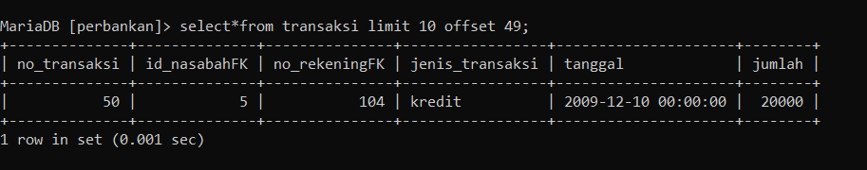

Create Code Python

Data Nasabah :

import mysql.connector

cnx = mysql.connector.connect(*user*='root',

*database*='perbankan')

cursor = cnx.cursor()

query = ("SELECT * FROM nasabah")

cursor.execute(query)

for (id_nasabah, nama_nasabah, alamat_nasabah) in cursor:

   print("Nasabah dengan Id {} bernama {} alamat {} " .format (

        id_nasabah, nama_nasabah, alamat_nasabah

 ))

cursor.close()

cnx.close()

Output :

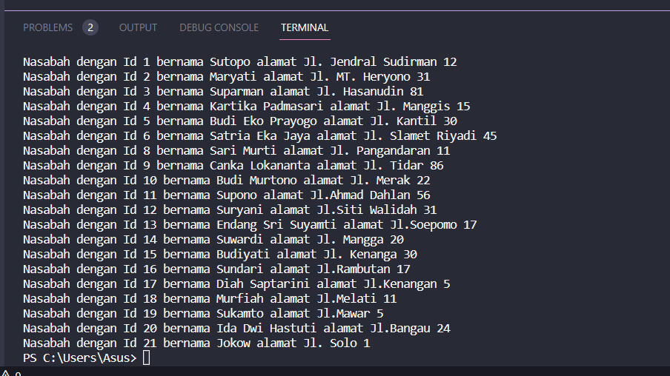

Data nasabah yang melakukan transaksi antara bulan oktober sampai desember:

import mysql.connector

cnx = mysql.connector.connect(*user*='root',

*database*='perbankan')

cursor = cnx.cursor()

query = ("SELECT DISTINCT nasabah.nama_nasabah",

DATE_FORMAT (transaksi.tanggal, '&M') AS nama_bulan "

        "FROM transaksi"

        "LEFT JOIN nasabah ON nasabah.id_nasabah = transaks.id_nasabahFK"

        "WHERE MONTH (transaksi.tanggal) BETWEEN 10 AND 12"

cursor.execute(query)

print("Nasabah yang melakukan transaksi pada bulan

Oktober sampai Desember:")

for (nama_nasabah, nama_bulan) in cursor:

    print("{} melakukan transaksi pada bulan {}".format(

        nama_nasabah, nama_bulan

 ))

cursor.close()

cnx.close()

Output:

